**Shri Ramdeobaba College of Engineering and Management, Nagpur**

**Department of Computer Science and Engineering**

**Session: 2024-2025**

**Name: Amber Shukla**

**Class :- A8**

**Roll 42**

**Fundamentals of Linux OS I Semester**

**PRACTICAL NO. 2**

**Aim: Experimentation with File system and file handling commands**

**Theory:**

# File Commands

* $ cat *filename* display the contents of file *filename*

$ cat > *filename* create a file with the name *filename*

$ cat >> *filename* append into the file *filename*

* $ touch *filename* create an empty file
* $ more *filename* display screenful content of the file;

press space bar to scroll and ctrl d to quit

* $ less *filename* same as more but also allows to move

backward and forward; press Ctrl **B** for

backward and space bar for forward

* $ cp *file1 file2* copy file1 to file2, overwrite old file2 if it

exists

* $ mv *file1 file2* move/rename file1 to file2, overwrite old

file2 if it exists, move file1 to file2 if file2 is

a directory

* $ rm *filenames* remove filenames

options : -i asks for confirmation before deleting the file

* $ ls list names of all files in current directory

options: -l list more information about each file

-**a** list all files, including hidden ones

-t list in time order, most recent first

-u list by time last used

-r list in reverse order

* $ ls *filenames* list only the named files
* $ wc *filename* count lines, words, and characters for each

file

options : -l count lines

-w count words

-c count characters

# Directory Commands

* $ pwd print current working directory
* $ mkdir *dirname* creates a directory
* $ cd *dirname* go to the directory
* $ cd go to home directory
* $ cd .. moves up one level in file system
* $ rmdir *dirname* removes the empty directory
* $ rm –r *dirname* recursively deletes the entire contents of the

directory as well as the directory itself

# Miscellaneous Commands

* $ grep *pattern file* display lines matching pattern

options : -v display lines not matching pattern

-i ignore case

-l display filenames instead of lines

-n prefix each line of output with line number

-x select only those matches that exactly match

the whole line

* $ sort *filname* sort files alphabetically by line

options : -r reverse normal order

-n sort in numerical order

-f fold upper and lower case together

$ tail *filename* display last 10 lines of file

options : -n display last n lines of file

* $ head *filename* display first 10 lines of file

options : -n display first n lines of file

* $ cmp *file1 file2* display location of first difference
* $ diff *file1 file2* display all differences between files

**EXPERIMENTATION:**

1. What is the purpose of blue and white color in ls command execution.

[Purpose of blue and white color in the ls command execution is to distinguish different types of files and directories](https://www.bing.com/ck/a?!&&p=3d4fe488abff8ff0JmltdHM9MTcyNzA0OTYwMCZpZ3VpZD0xNzNmOGY3Yy0yNmExLTYwYmQtMmY1ZS05YmMxMjc2ODYxYzcmaW5zaWQ9NTY2NA&ptn=3&ver=2&hsh=3&fclid=173f8f7c-26a1-60bd-2f5e-9bc1276861c7&psq=1)+What+is+the+purpose+of+blue+and+white+color+in+ls+command+execution.&u=a1aHR0cHM6Ly9pdHNmb3NzLmNvbS9scy1jb2xvci1vdXRwdXQv&ntb=1" \t "_blank)

1. Display your current directory.

cd

1. List all the files (including hidden files) in your home directory

list -a

1. Go to path /home/<your username>

cd mkdir AMBER

1. Create directory structure as follows

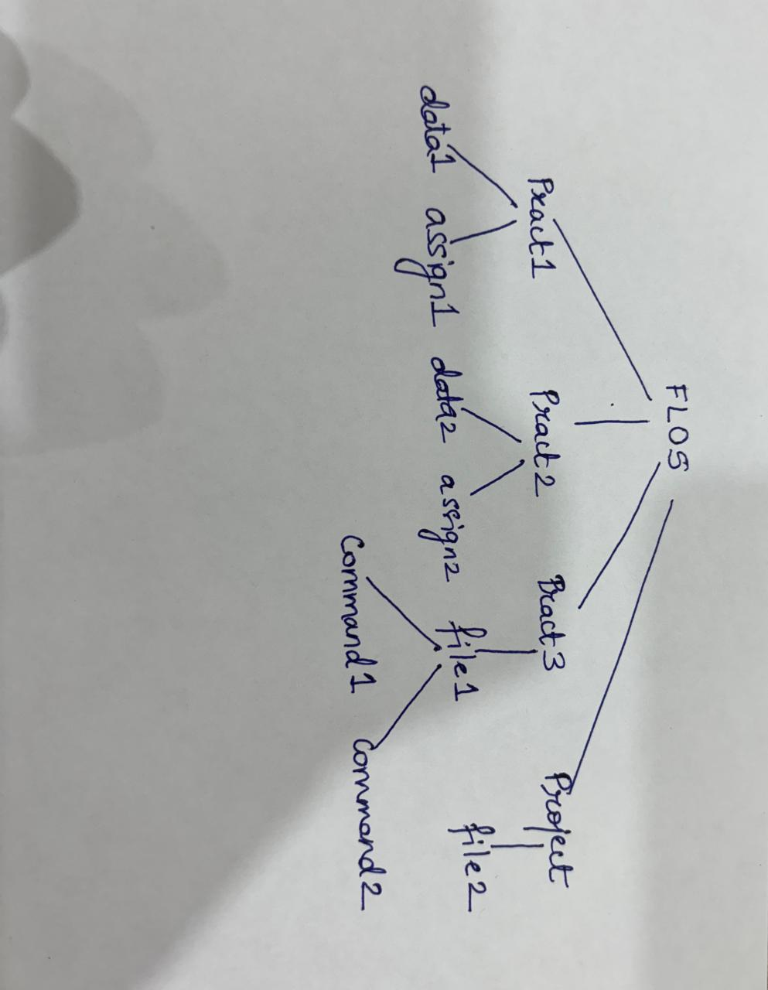

mkdir AMBER

mkdir PRACT1

mkdir PRACT2

mkdir PRACT3

mkdir project

cd PRACT1

cd ..

mkdir data1 assign 1

cd PRACT2

mkdir data2 assign2

cd ..

cd PRACT3

mkdir file 1

cd ..

cd project

mkdir file 2

cd..

cd..

cd file 1

mkdir Command 1 Command 2

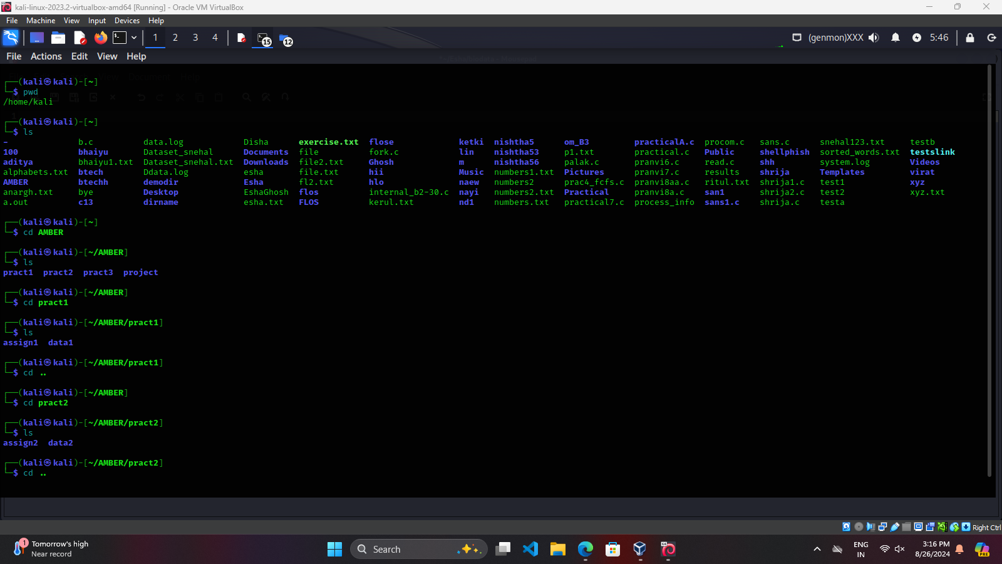

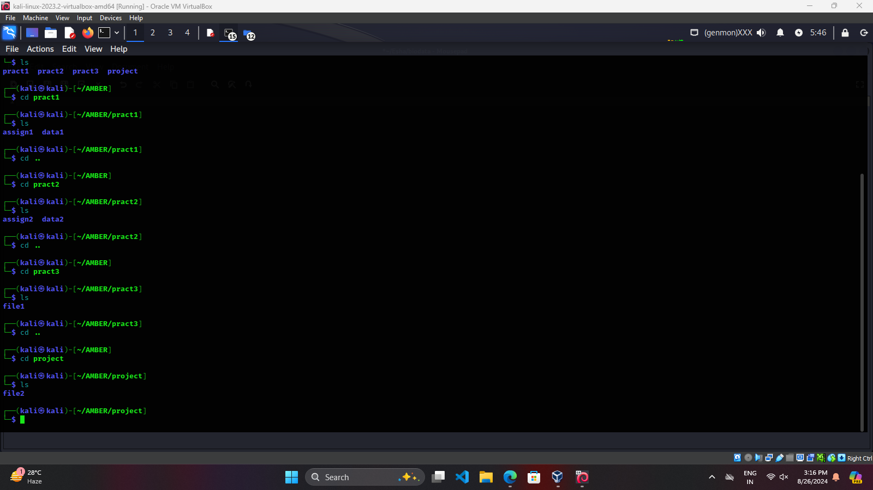

1. Do as directed:
2. Change directory to FLOS

mkdir AMBER

1. Change directory to file1 using single command

cd kali/Desktop/AMBER/PRACT3/file1

1. Go back to immediate parent directory from file 1

cd ..

1. Delete the directory file1

rm -r file 1

1. Show the contents of pract3

ls PRACT 3

1. Create an empty file (file1.txt) in data1 directory

cat>file1.txt

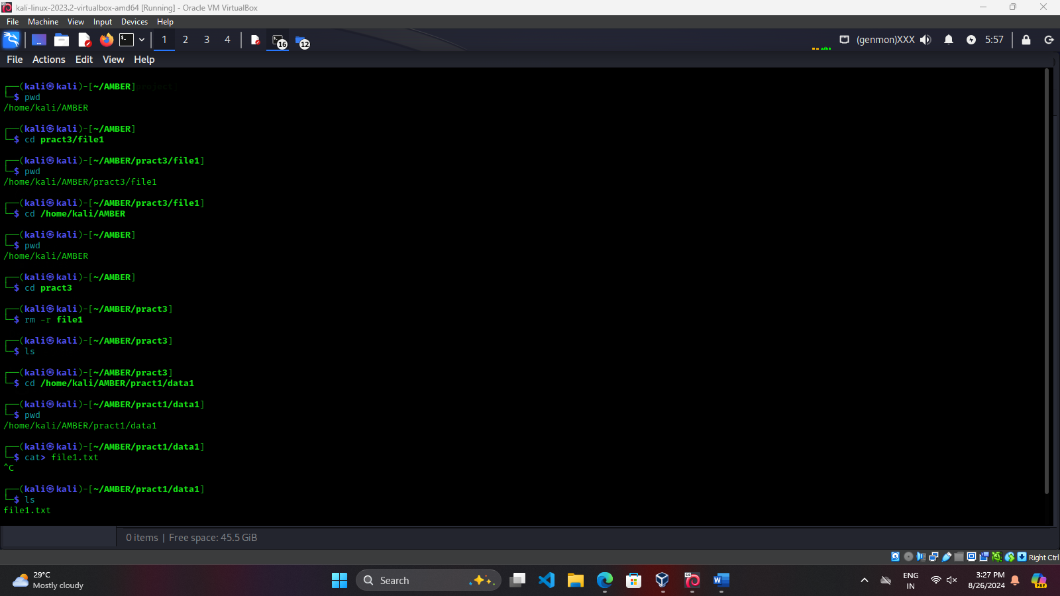

1. Write student names in file1.txt (one name per line)- Also write the name “Aryan” 5 times.

cat file1.txt

Aryan

Aryan

Aryan

Aryan

Aryan

1. Display the count of lines, words, and characters in file1.txt

wc file1.txt

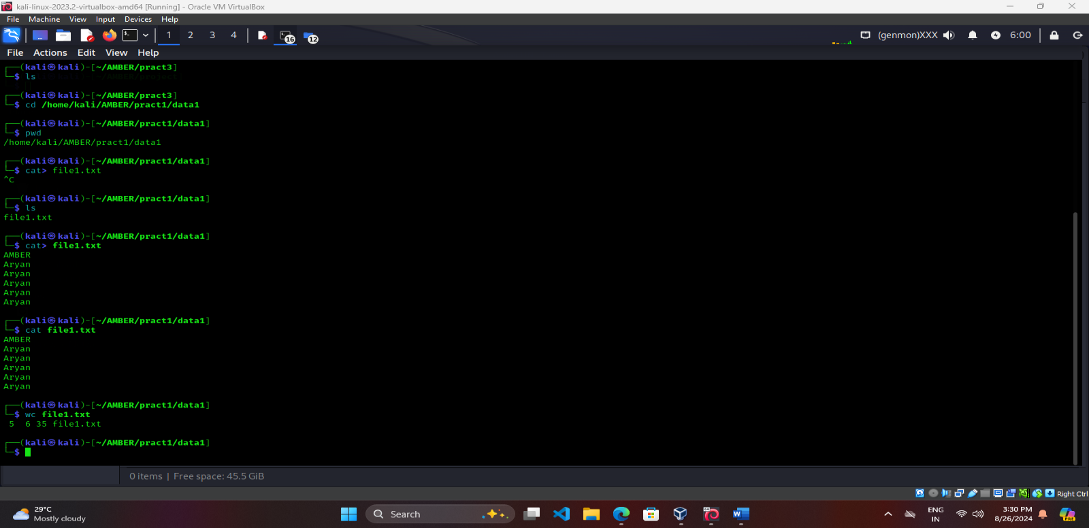

1. Copy all the contents of file1 to file2 (let file 2 be in the same directory)

cp file1.txt file2.txt

1. Rename file2 to file3

mv file2.txt file3.txt

1. Display the contents of file3 using different methods- display entire content, display last 3 lines, display first 3 lines

cat file3.txt

tail -n 3 file3.txt

head -n 3 file3.txt

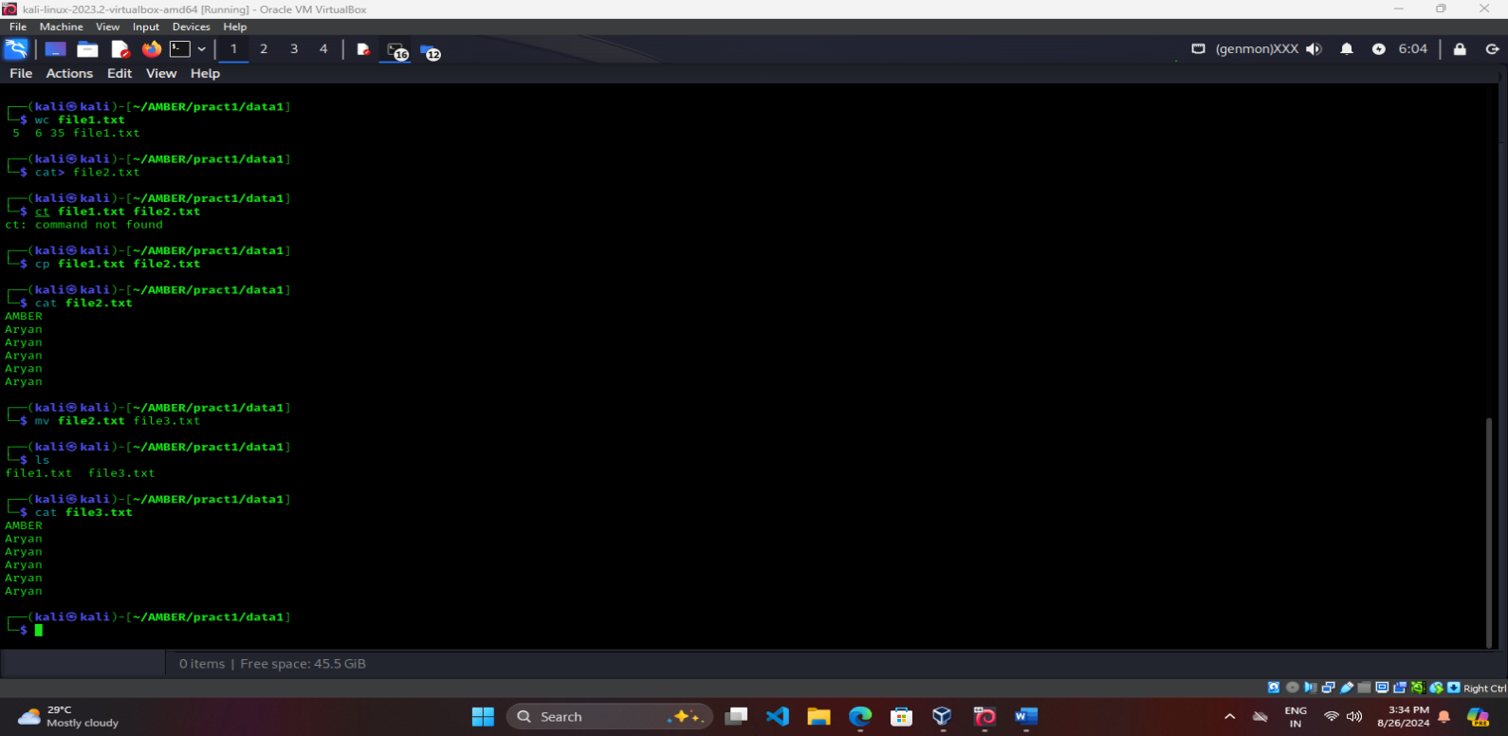

1. Delete file1.txt

rm file1.txt

1. Display student names alphabetically (from file3.txt)

sort file3.txt

1. Display the count of occurrence of “Aryan” in file3.txt using grep command grep Aryan file3.txt 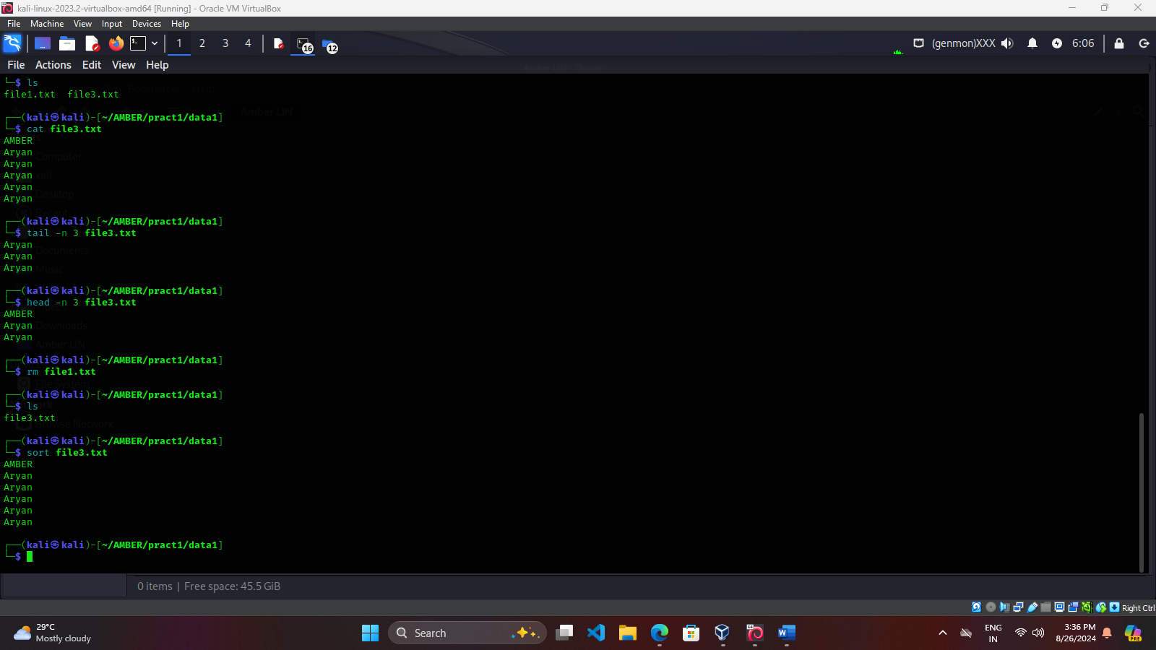
2. Create a file (file4.txt) in data2 directory with numbers and display sorted numbers in reverse.

cd PRACT2/data2

cat>file4.txt

4

8

2

7

9

1

3

sort -r file4.txt

1

2

3

4

7

8

9

